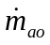 - mass flow rate of air out of intake manifold
MAX - maximum flow rate corresponding to fully open throttle valve
TC - normalized throttle characteristic
- throttle angle
PRI - normalized pressure influence function
PR - pressure ratio
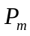 - intake manifold pressure
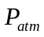 - atmospheric pressure
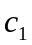 -
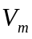 - volume of intake manifold
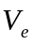 - engine displacement
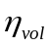 - volumetric efficiency
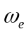 - angular velocity of engine
- manifold pressure
R - universal gas constant for air
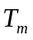 - temperature of intake manifold
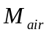 - molecular weight of air
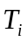 - engine indicated torque
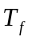 - engine friction torque
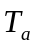 - engine accessory torque
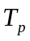 - engine pump torque
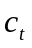 - max torque capacity of an engine for a given air mass, engine speed, AFI and SI = 1 also known as the engine torque constant
AFI - normalized air fuel influence function
SI - normalized spark influence function
A/F - air-to-fuel ratio
SA - spark advance\retard from top dead center (TDC)
MBT - minimum spark advance for best torque
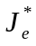 - effective engine inertia
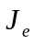 - engine and torque converter inertia
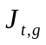 - transmission inertia in gear
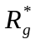 - a variable that depends on the vehicle transmission gear ratio
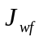and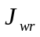 - combined inertias of both front and rear wheels
M - vehicle mass
h - effective tire radius
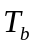 - combined brake torque
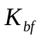and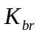 - front and rear brake torque constant of proportionality
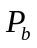 - brake pressure
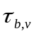 - vehicle brake torque time constant

